32.21: a) The momentum density 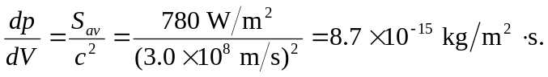
b) The momentum flow rate 